AfricaAI: Runbook – SWEPENFND – AP2
Summary | We are collecting specific line-items (allocation data and asset levels data) from the reports.
Source name | Andra AP-fonden (AP2) – AP2
Link to the source | https://ap2.se/en/news-and-reports/reports/financial-reports/
Dataset name | Pension Funds Data (Sweden) - SWEPENFND
Frequency | Annual  Semi-Annual
SLA | Annual SLA: Start checking for the annual report in mid-February (first weekday after 2/15). Check on a daily basis; we expect the annual report to come out in February  Semi-annual SLA: Start checking for the semi-annual report in mid-July (first weekday after 7/15), once a week on Monday thereafter
Expected Time | NA

Instructions:
NB! This data should be processed only via your AWS workspace.
Annual Task
- Navigate to the table titled "five-year overview". Capture each line from the "Fund Capital, Flows and Results" sections as individual, annual measures
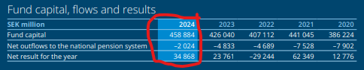
CODE | DESCRIPTION
AP2.FUNDCAPITALCARRIEDFORWARD.LEVEL.NONE.A.1@AP2 | AP2 annual: Fund capital carried forward
AP2.NETOUTFLOWSTOTHENATIONALPENSIONSYSTEM.FLOW.NONE.A.1@AP2 | AP2 annual: Net outflows to the national pension system
AP2.TOTAL.FLOW.NONE.A.1@AP2 | AP2 annual: Net result for the year

- Navigate to the table titled "Asset class exposure". Capture each line from the "Strategic Portfolio, %" and " %" (2nd column) columns as an individual, annual DF series
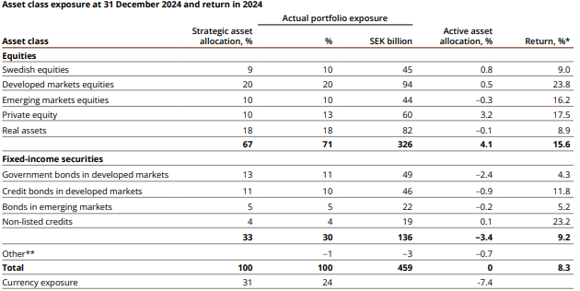
CODE | DESCRIPTION
AP2.DOMESTICEQUITIES.ACTUALALLOCATION.STRATEGICPORTFOLIO.NONE.A.1@AP2 | AP2 annual: Strategic portfolio - Swedish equities
AP2.DEVELOPEDEQUITIES.ACTUALALLOCATION.STRATEGICPORTFOLIO.NONE.A.1@AP2 | AP2 annual: Strategic portfolio - Developed markets equities
AP2.EMERGINGEQUITIES.ACTUALALLOCATION.STRATEGICPORTFOLIO.NONE.A.1@AP2 | AP2 annual: Strategic portfolio - Emerging markets equities
AP2.DOMESTICEQUITIES.ACTUALALLOCATION.NONE.A.1@AP2 | AP2 annual: Exposure - Swedish equities
AP2.DEVELOPEDEQUITIES.ACTUALALLOCATION.NONE.A.1@AP2 | AP2 annual: Exposure - Developed markets equities
AP2.EMEQUITIES.ACTUALALLOCATION.NONE.A.1@AP2 | AP2 annual: Exposure - Emerging markets equities
AP2.EQUITIES.ACTUALALLOCATION.STRATEGICPORTFOLIO.NONE.A.1@AP2 | AP2 annual: Strategic portfolio - Equities
AP2.PRIVATEEQUITY.ACTUALALLOCATION.STRATEGICPORTFOLIO.NONE.A.1@AP2 | AP2 annual: Strategic portfolio - Private Equity
AP2.REALASSETS.ACTUALALLOCATION.STRATEGICPORTFOLIO.NONE.A.1@AP2 | AP2 annual: Strategic portfolio - Real assets
AP2.FIXEDINCSECURITIES.ACTUALALLOCATION.STRATEGICPORTFOLIO.NONE.A.1@AP2 | AP2 annual: Strategic portfolio - Fixed-income securities
AP2.GOVBONDSDEVMARKETS.ACTUALALLOCATION.STRATEGICPORTFOLIO.NONE.A.1@AP2 | AP2 annual: Strategic portfolio - Government bonds in developed markets
AP2.CREDITBONDSDEVMARKETS.ACTUALALLOCATION.STRATEGICPORTFOLIO.NONE.A.1@AP2 | AP2 annual: Strategic portfolio - Credit bonds in developed markets
AP2.BONDSEMMARKETS.ACTUALALLOCATION.STRATEGICPORTFOLIO.NONE.A.1@AP2 | AP2 annual: Strategic portfolio - Bonds in emerging markets
AP2.NONLISTEDCREDITS.ACTUALALLOCATION.STRATEGICPORTFOLIO.NONE.A.1@AP2 | AP2 annual: Strategic portfolio - Non-listed credits
AP2.OTHER.ACTUALALLOCATION.STRATEGICPORTFOLIO.NONE.A.1@AP2 | AP2 annual: Strategic portfolio - Other
AP2.TOTAL.ACTUALALLOCATION.STRATEGICPORTFOLIO.NONE.A.1@AP2 | AP2 annual: Strategic portfolio - Total
AP2.CURRENCYEXPOSURE.ACTUALALLOCATION.STRATEGICPORTFOLIO.NONE.A.1@AP2 | AP2 annual: Strategic portfolio - Currency exposure
AP2.EQUITIES.ACTUALALLOCATION.NONE.A.1@AP2 | AP2 annual: Exposure - Equities
AP2.PRIVATEEQUITY.ACTUALALLOCATION.NONE.A.1@AP2 | AP2 annual: Alternative investments - Private equity
AP2.REALASSETS.ACTUALALLOCATION.NONE.A.1@AP2 | AP2 annual: Exposure - Real assets
AP2.FIXEDINCSECURITIES.ACTUALALLOCATION.NONE.A.1@AP2 | AP2 annual: Exposure - Fixed-income securities
AP2.GOVBONDSDEVMARKETS.ACTUALALLOCATION.NONE.A.1@AP2 | AP2 annual: Exposure - Government bonds in developed markets
AP2.CREDITBONDSDEVMARKETS.ACTUALALLOCATION.NONE.A.1@AP2 | AP2 annual: Exposure - Credit bonds in developed markets
AP2.BONDSEMMARKETS.ACTUALALLOCATION.NONE.A.1@AP2 | AP2 annual: Exposure - Bonds in emerging markets
AP2.NONLISTEDCREDITS.ACTUALALLOCATION.NONE.A.1@AP2 | AP2 annual: Exposure - Non-listed credits
AP2.OTHER.ACTUALALLOCATION.NONE.A.1@AP2 | AP2 annual: Exposure - Other
AP2.TOTAL.ACTUALALLOCATION.NONE.A.1@AP2 | AP2 annual: Exposure - Total
AP2.CURRENCYEXPOSURE.ACTUALALLOCATION.NONE.A.1@AP2 | AP2 annual: Exposure - Currency exposure

- Navigate to the Pie-Chart titled "Real assets". Capture each line item from the PIE-Chart as an individual, annual measures.
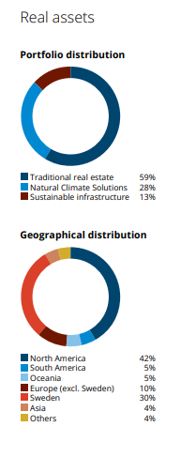
CODE | DESCRIPTION
AP2.TRADITIONALREALESTATE.ACTUALALLOCATION.NONE.A.1@AP2 | AP2 annual: Real Assets, Portfolio distribution - Traditional real estate
AP2.NATURALCLIMATE.ACTUALALLOCATION.NONE.A.1@AP2 | AP2 annual: Real Assets, Portfolio distribution - Natural Climate Solutions
AP2.SUSTAINABLEINFRASTRUCTURE.ACTUALALLOCATION.NONE.A.1@AP2 | AP2 annual: Real Assets, Portfolio distribution - Sustainable infrastructure
AP2.NORTHAMERICA.ACTUALALLOCATION.NONE.A.1@AP2 | AP2 annual: Real Assets, Geographical distribution - North America
AP2.SOUTHAMERICA.ACTUALALLOCATION.NONE.A.1@AP2 | AP2 annual: Real Assets, Geographical distribution - South America
AP2.OCEANIA.ACTUALALLOCATION.NONE.A.1@AP2 | AP2 annual: Real Assets, Geographical distribution - Oceania
AP2.EUROPE.ACTUALALLOCATION.NONE.A.1@AP2 | AP2 annual: Real Assets, Geographical distribution - Europe (excl. Sweden)
AP2.SWEDEN.ACTUALALLOCATION.NONE.A.1@AP2 | AP2 annual: Real Assets, Geographical distribution - Sweden
AP2.ASIA.ACTUALALLOCATION.NONE.A.1@AP2 | AP2 annual: Real Assets, Geographical distribution - Asia
AP2.OTHERS.ACTUALALLOCATION.NONE.A.1@AP2 | AP2 annual: Real Assets, Geographical distribution - Others

- Collect values for both years for each line item for the table from report below:
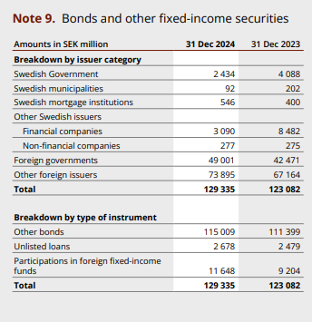

Semiannual Task
1. Navigate to the table titled "key ratios". Capture each line from the first section as an individual, semiannual measure:
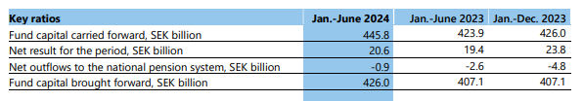
2. Collect all items from the table below as annual data points:
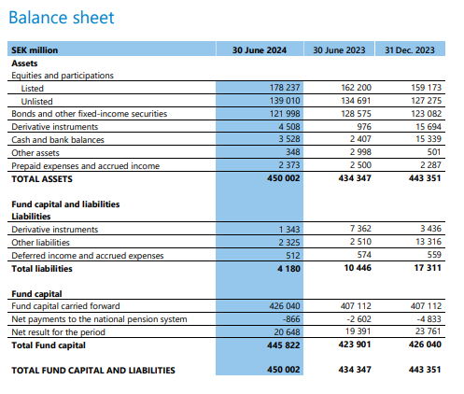
Requirements to the data provided by AfricaAI
Data files format
For on-boarding new datasets and processing new releases the following requirements are applied:
- there should be one archive in .ZIP format that contains 2 files provided in .XLS format per one release - one file with DATA and one file with METADATA (both files are mandatory). Archive name should be as "DATASET_YYYYMMDD.ZIP"", where "DATASET" - specified abbreviation for a dataset, "YYYYMMDD" - timestamp when the file was created, where YYYY - year, MM - month number, DD – day;
- the files format is strictly defined and cannot be changed by AfricaAI team.

File with DATA
Template for file name: “DATASET_DATA_YYYYMMDD.xls”, i.e.” MEXPENFND_DATA_20220601.xls”
Requirements to the file with DATA:
- format - XLS, encoding - Unicode (UTF-8);
- file name: should follow pattern "DATASET_DATA_YYYYMMDD.xls", where "DATASET" - specified abbreviation for a dataset, "YYYYMMDD" - timestamp when the file was created, where YYYY - year, MM - month number, DD - day;
- file content:
  - for data with daily/ weekdaily frequency: YYYY-MM-DD, where YYYY - year, MM - month, DD – day;
  - for data with weekly frequency: YYYY-WW, where YYYY - year, WW - week number (should be two-digits, i.e. 2022-01, 2022-02, etc.). Week number is defined based on the reporting date: reporting date is considered the end of the week, i.e. if reporting date is Wednesday the week is calculated from Thursday till Wednesday – based on that rule the number of the week is defined;
  - for data with monthly frequency: YYYY-MM, MM - month number (should be two-digits, i.e. 2022-01, 2022-02, etc.);
  - for data with quarterly frequency: YYYY-QX, where YYYY - year, X - quarter number;
  - for data with annual frequency: YYYY, where YYYY – year;
  - if provider specifies for reported period that data is Not Available (that could provided in corresponding notes or other way) - fill in that data point with "NA" value;
  - if provider does not specify that data is Not Available and report Empty value for reported period - leave Empty cell;
  - if provider skips some of reporting period - skip it also in the file with data as well;
  - data is provided on one sheet only (multiple sheets are forbidden);
  - two-dimensional format where rows represent reported periods and columns contain timeseries values;
  - reported period(s) should be provided in the following format:
  - values to be provided in decimal format with "." as delimiter (number of digits after "." is limited only by provided value by the source). In order to interpret data correctly the following requirements are applied:
  - column names to be provided in two first rows: in the first row - timeseries ID (CODE), in the second row – timeseries description (description in DATA file is identical to description in file with METADATA).
NB! Timeseries with different frequencies could be provided within the same file as there are different patterns for providing reported periods

File with METADATA
Template for file name: “DATASET_META_YYYYMMDD.xls”, i.e.” MEXPENFND_META_20220601.xls”
Requirements to the file with METADATA:
- format - XLS, encoding - Unicode (UTF-8);
- file name: should follow pattern "DATASET_META_YYYYMMDD.xls", where "DATASET" - specified abbreviation for a dataset, "YYYYMMDD" - timestamp when the file was created, where YYYY - year, MM - month number, DD - day;
- file content: specified metadata attributes that are static unless provider changes something or new timeseries should be added. In case of new timeseries should be added/ updated/ changed - escalate that to Data Engineering team Special BWAT-DFAC Data Engineering <SpecialBWAT-DFACDataEngineering@epam.com> at and Cc: Data Operations team at Special BWAT-DFAC DataOps <SpecialBWAT-DFACDataOps@epam.com>

Notes on METADATA fields from file “DATASET_META_YYYYMMDD.xls”
- With every data release attach file with METADATA
- With every release change only on attribute in the file with METADATA in column “NEXT_RELEASE_DATE” – set “YYYY-MM_DDThh:mm:ss” (YYYY – year, MM – month, DD – day, hh – hour, mm – minutes, ss – seconds. Time should be provide in UTC time) to the time when the next release is going to be processed.

Saving ZIP archive on SFTP
Save the releases in specified per “DATASET” folder (you may create new folder for new DATASET in case of absence of such folder).
Details on SFTP are the following:
1) Dev env
Host: africaai.datadev.dfac.io
2) PRODVAL env
Host: africaai.prodval.data-factory.io
3) PRODHA env
Host: africaai.prodha.data-factory.io
Port: 22

